Understanding Friedman’s H-statistic (H-stat) for Interactions

The intuition and maths for the H-stat used to find interactions in machine learning models
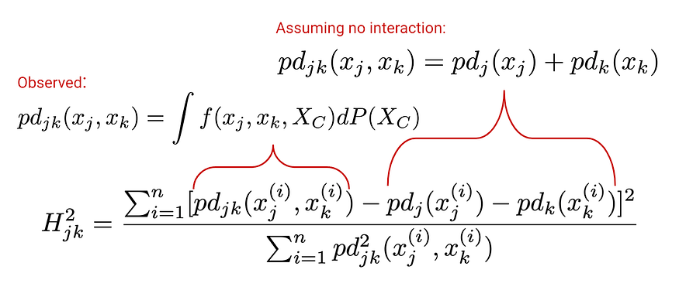
Inhaling asbestos increases the chance of lung cancer more for smokers than non-smokers. The side effects of medication can depend on your gender. Your car will decrease in value with age — unless it is a classic car. These are all examples of interactions. Identifying and incorporating these can drastically improve the accuracy and change the interpretation of your models. The question is how do we find them?
One approach is to apply Explainable AI methods to a model train on features you expect may be interacting. We will explore one of these methods— Friedman’s H-statistic. This is also known as the H-stat or H-index. Specifically, we will:
- Give the intuition behind the method with the help of PDPs and ICE Plots.
- Explain the maths in-depth.
- Understand its limitations and how to overcome them.
We will see that there are two versions of the statistic. One for the interaction between two features and another for the interaction between a feature and all other features. When exploring the limitations, we will also see there is a non-normalised version of the metric.

Definition of an interaction effect
Before we get to that, let the formulary define what we mean by an interaction. This will help us understand what we are trying to measure using the H-stat. We take this definition from the paper that introduces the H-stat[1]:
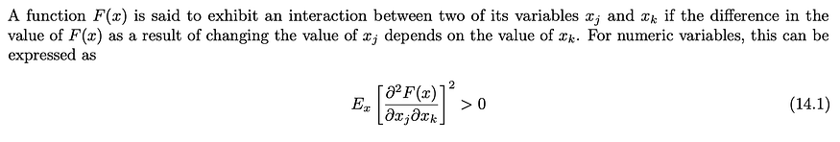
The partial derivative can be interpreted as the rate of change of, the rate of change of the function w.r.t feature j, w.r.t feature k. If the expected value is 0 then the rate at which the function changes w.r.t to feature j does not change when feature k changes and visa versa.
With machine learning, F is our model or, in other words, the prediction function. A model will learn interactions from relationships within a dataset. Yet, when we say two features interact, we mean they interact within a model.

The Intuition (relationship with PDPs and ICE Plots)
If you couldn’t tell by the last part, this chapter is fairly maths-heavy. To make it easier to understand let’s build some intuition around how the H-stat seeks to quantify interactions in a model. To do this, we’ll use some of the plots we saw in a previous article on PDPs and ICE plots. We will see that the H-stat is related to these.
We used these methods to understand the relationships of various features used by a model to predict the price of a second-hand car. In Figure 1, we have the PDP for one of those features — car_age. This gives the average predicted price of a second-hand car as the car’s age increases. We can see that, in general, the price decreases with age.
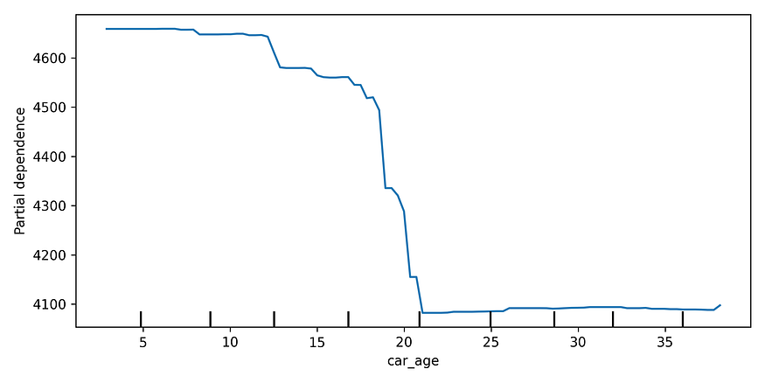
Figure 1: partial dependence plot for car_age
The car_type feature had two classes — either classic or normal. We can see the PDP for this feature in Figure 2. Classic cars tend to have a higher price on average. Both of the relationships for car_age and car_type are intuitive but what if we want to understand the joint PDP of the two features?
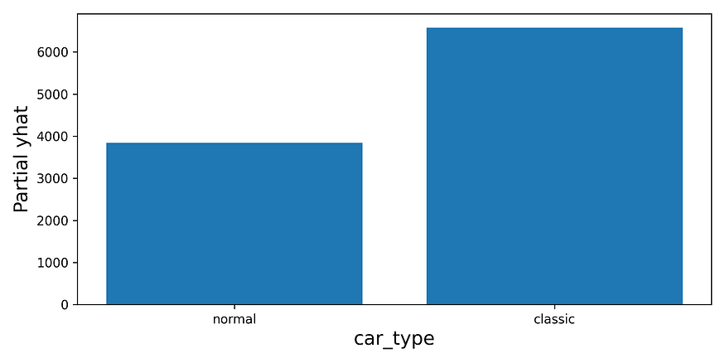
Figure 2: PDP for the categorical feature displayed as a boxplot
If there is no interaction between the features, the joint PDP will be additive. For a given instance, we could simply add the value from the car_age PDP to the value from the car_type PDP. (Provided, we then centre the joint PDP.) This property comes from our definition of an interaction. If there is no interaction, then the change in the prediction w.r.t car_age will not depend on the value of car_type and visa versa.
However, we also had the ICE plot in Figure 3. We can see there is clearly an interaction between these two features. For classic cars, the effect of car_age on predicted price will be different than for normal cars. So, if we added the values from the car_age PDP to the PDP value for classic cars, we would underestimate the effect of age for these cars. In other words, the PDPs are not additive.
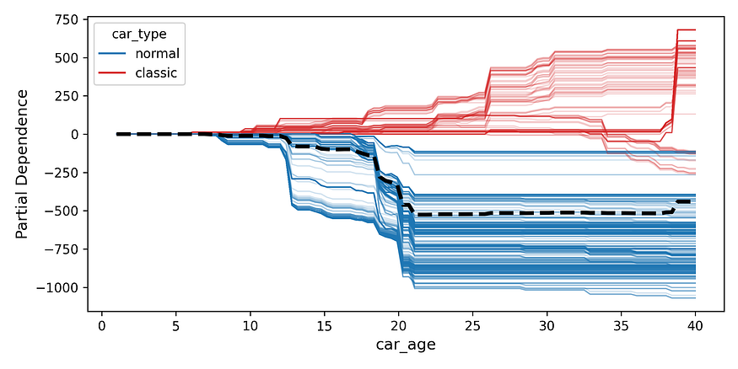
Figure 3: ICE plot showing the interaction between car_age and car_type
This is the key to understanding the H-stat — we compare the observed joint PDP to the joint PDP under the assumption that there is no interaction between two features. We can also extend this concept to analyse interactions between a feature and all other features in the model. Let’s move on to a more formal explanation for this.

The mathematics of the H-stat
In the previous article, we also discussed the formula for PDPs. Specifically, we had PD function seen in Equation 1. Remember S is a set of features and C is the set of features excluding those in S. To find the PD function of S, we integrate our model function (f) w.r.t. the probability of observing the values in set C. If we set S ={car_age}, then we would get the equation for the blue line we saw in Figure 1.
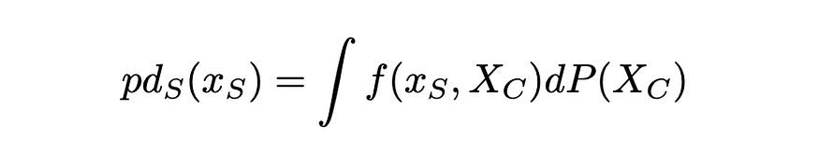
Equation 1
Now, suppose S consists of two features j and k. We want to understand if these features interact. Following the above equation, Equation 2 gives the joint PD function of features j and k. The H-stat compares this PD to the same PD under the assumption that there is no interaction.
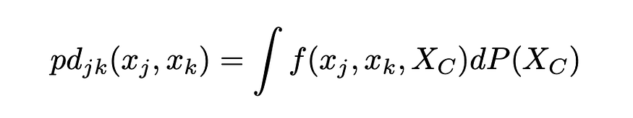
Equation 2
What does this PD look like? Well, if we assume that j and k do not interact, we can reformulate their joint PD as the sum of the two individual PDs. We can see this in Equation 3.
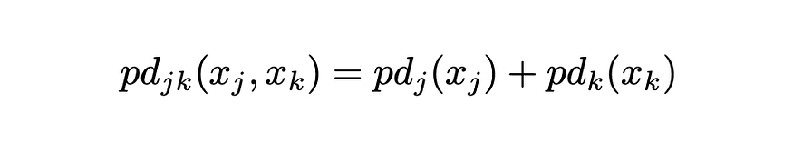
Equation 3
Now we won’t get into the proof for this (a.k.a I’m too lazy to understand it). We already discussed the intuition above but let’s try to gain even more intuition for why Equation 3 is correct. It follows from this mathematical theorem [1]:
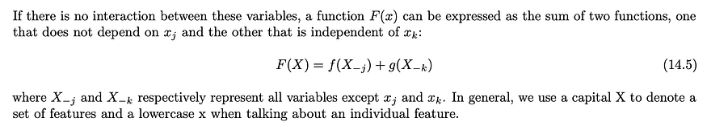
It is easy to show that this theorem is valid for linear regression. Take the regression function F(X) where X consists of our two features j and k.
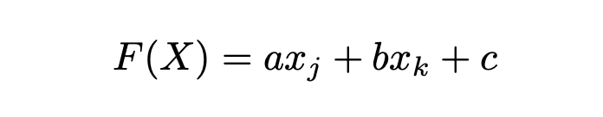
Two potential functions are:
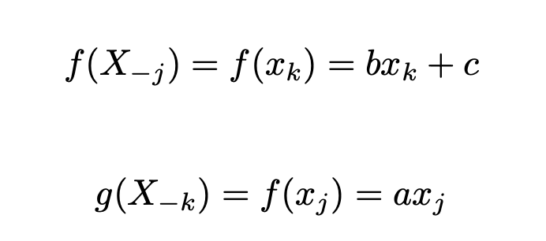
If j and k do interact, we would have to include an interaction term such as the one below. Now, I challenge you to find two functions f and g!
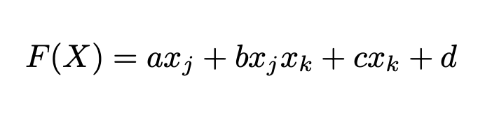
The theorem does not only apply to prediction functions. This is true for any function of our features such as PDs. If you are concerned about pesky constants, remember we can centre our PDs around any values to get rid of them. Okay, so that explains Equation 3. Now let’s see how we can compare it to the observed joint PD.

Interaction between two features
Equation 4 gives the H-stat for the interaction between two features j and k. Let’s break this down:
- In the numerator, we have the value of PD in Equation 2 minus the PD in Equation 3.
- We square this so both positive and negative differences contribute to the H-stat.
- In the denominator, we normalise the difference by dividing by the square of the PD in equation 2.
- We sum these values over n instances.
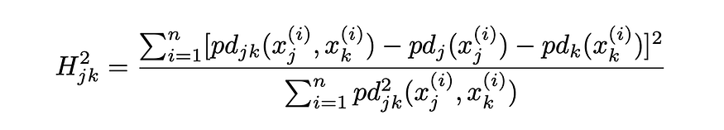
Equation 4
By normalising, the H-stat will tend to be between 0 and 1. The value has a useful interpretation. To understand it let’s consider the extremes:
- If there is no interaction, then the joint PDP will be the same as the additive PD. The numerator will be 0 and so the H-stat will be 0.
- If the two features only affect the prediction through an interaction (i.e. no main effects) then both individual PDPs will be constant. The numerator will be the same as the denominator and the H-stat will have a value of 1.
In other words, we can interpret the H-stat as the percentage of variance in the joint PD that comes from the interaction between the two features. Or more simply, the percentage of the effect on a prediction that comes from interactions between the features. However, there are cases where the H-stat will be larger than 1. This can happen due to statistical variation or if the main effects cancel each other out and the variance of the interaction is larger than the variance of the joint PD.

Interaction with any feature
We can extend this idea to understand if a feature interacts with any other feature in a model. We call this the overall H-stat. To start, we can extend the mathematical theorem we introduced above [1]. That is:
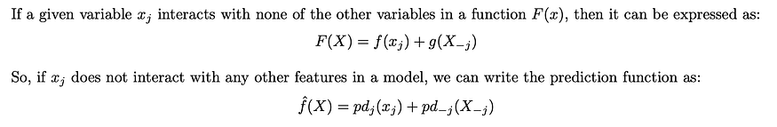
Finally, to calculate the H-stat we have Equation 5. This compares the prediction function to the prediction function under the assumption that j does not interact with any other features. If this assumption is true, the H-stat will have a value of 0. If j only affects the prediction through interactions then we will have a value of 1.
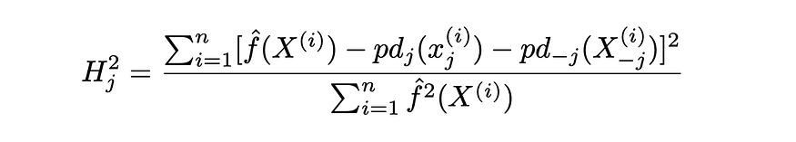
Equation 5
Combined the H-stat and ICE plots are effective tools for analysing interactions in your model. We can first use the overall H-stat to find features with important interactions and then the individual H-stats to find the features they interact with. Once we have a list, ICE plots can visualise them to understand their nature. Yet, like ICE Plots the H-stat still has its limitations.

The limitations of H-stat

Complexity
The first is that the H-stat is computationally expensive. It is often impractical to calculate it for the entire dataset or even a fairly large sample. As a result, we may have to take a small sample of instances from our dataset. This can lead to issues around the variability in the H-stat. We’ll explore this in a later article when applying the H-stat.

Over-exaggerated interactions
As mentioned above, the H-stat tells us the proportion of variation in the joint PDP explained by the interaction between two features. This does not tell us how much the interaction has actually affected the prediction.
Consider the case where two features only affect the prediction through an interaction but those effects are close to 0. This means the numerator in Equation 4 will be small. However, the denominator will also be close to 0. By dividing by this small value we can end up with a large H-stat. Additionally, minor changes due to statistical variation and sampling can result in large swings in the H-stat.
Ultimately, we can be misled to believe that an interaction is significant. To avoid this a non-normalised version of the H-stat, as seen in Equation 6, has been proposed. This is the square root of the numerator from Equation 4.
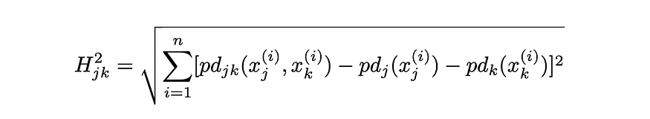
Equation 6
We do however lose the useful interpretation from the original equation. So, as another alternative, we can stick with the original equation and use a measure of feature importance such as Permutation Feature Importance or mean SHAP. This will allow us to understand which features make significant contributions to the prediction.

Spurious interactions
Another way the H-stat can mislead us is by identifying interactions when features are actually highly correlated. We call these spurious interactions. To understand why we can consider how tree-based methods model non-linear relationships. The reasons are similar for other non-linear models.
Suppose income has a non-linear relationship with credit score. More specifically, income in the last 12 months — INCOME. To model this with a single tree, we would have to include multiple splits of the INCOME feature such as seen in Tree 1.
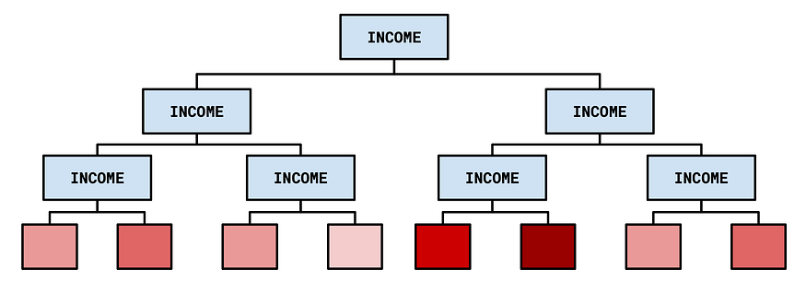
Tree 1 — decision tree used to model a non-linear relationship between credit score and INCOME
Suppose we also had another income feature in our feature set. INCOME_6 is income in the last 6 months. The two income features would likely be highly correlated and have a similar relationship with the target variable. This means we could capture the same non-linear relationship using different income features at each level of the tree. Such as seen in Tree 2. Within an ensemble method, this can happen multiple times in different trees.
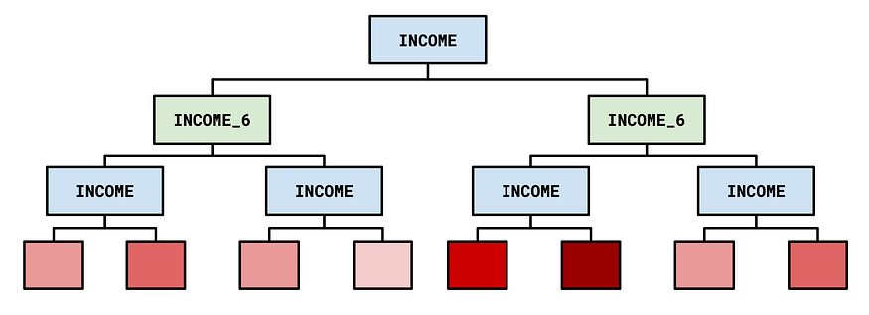
Tree 2 — non-linear relationship captured using different income features (source: author)
The problem is this is exactly how a tree method captures an interaction between two features. By consistently having the same two features in a tree, we can capture the effect of one of the features at different values of the other feature. Ultimately, using a metric like the H-stat, it will look like there is an interaction between INCOME and INCOME_6 when, in fact, the features are highly correlated.

